Arman Adilbek
SE-2432
Objective
By the end of this assignment, I created my first HTML webpage using basic and intermediate HTML tags. I learned how to structure text, create lists, insert images and links, build tables and forms, and finally publish the webpage.
Step 0 – HTML Boilerplate
- Created a file named index.html.
- Wrote the basic HTML structure (<!DOCTYPE html>, <html>, <head>, <title>, <body>).
- Titled the page as “My First Website”.
- 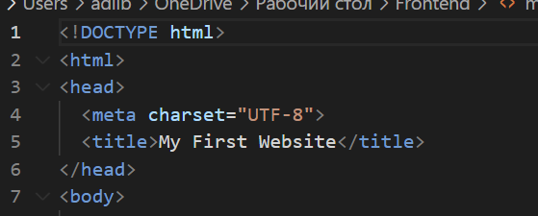
Step 1 – Headings and About Me
- Added headings <h1>, <h2>, <h3> with my name, course, and “About Me”.
- Inserted a paragraph describing myself.
- Added my photo using <img>.
- 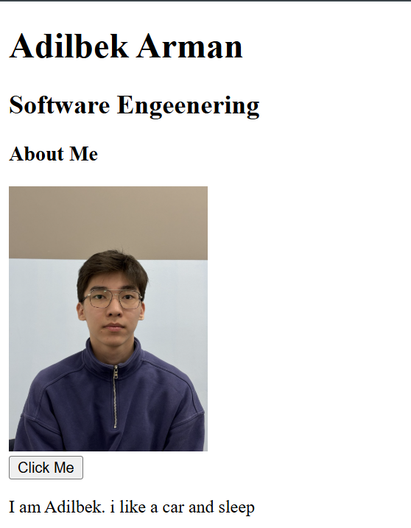
- 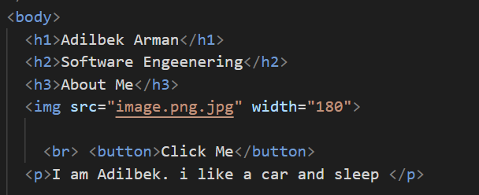
Step 2 – Lists
- Created an ordered list <ol> for my hobbies.
- Created an unordered list <ul> for my favorite websites with links.
- 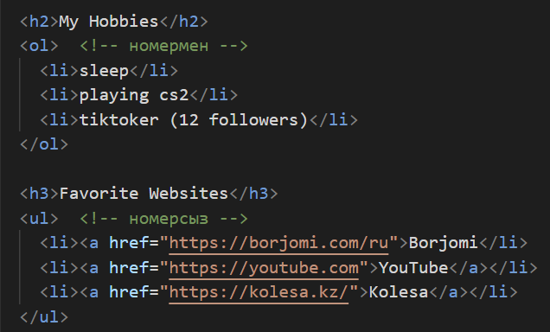
Step 3 – Links
- Added links to websites (Borjomi, YouTube).
- 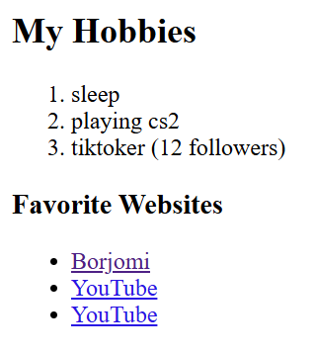
Step 4 – Buttons
- Added a simple button with text “Click Me”.
Step 5 – Tables
- Built a weekly class schedule using <table>.
- Added columns: Time, Monday, Tuesday, Wednesday, Thursday, Friday, Saturday.
- Filled in my real schedule with subjects, teachers, and rooms.
- 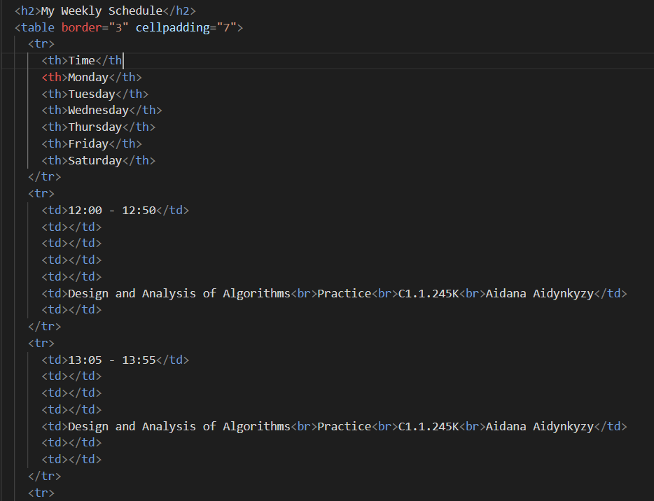
- 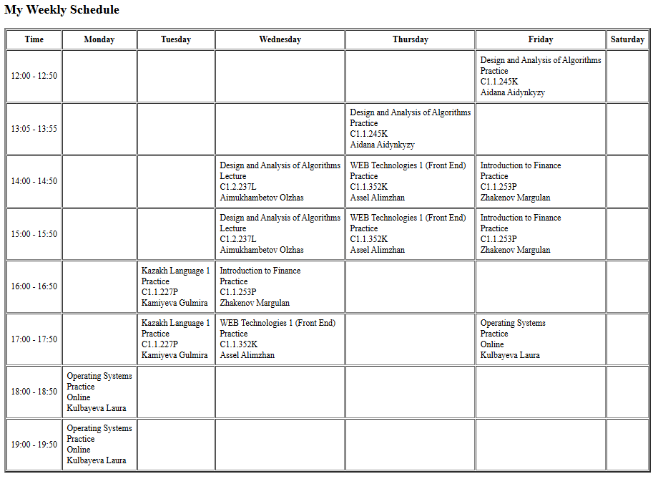
Step 6 – Emojis
- Added emojis inside paragraphs about my mood: 🫠 😒 😀.
- 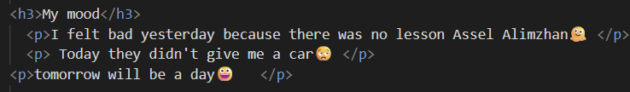
- 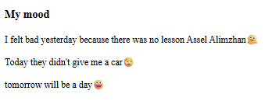
Step 7 – Forms
- Created a form with fields: Name, Email, Favorite Color, and a Submit button.
- 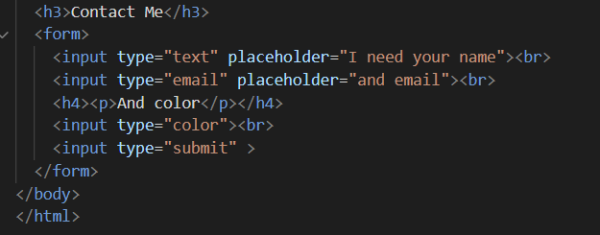
- 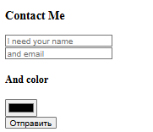
Publishing
- Project was prepared for publishing GitHub Pages
- Files are working without errors.
- Link - https://github.com/XelVarful/Frontend.git
Summary
In this assignment, I:
- Learned how to create a webpage with HTML basics.
- Practiced using text, lists, images, links, tables, and forms.
- Made a personalized webpage with my hobbies, schedule, and contact form.
- Improved my understanding of HTML structure and tags.
This assignment helped me build my first working website.

